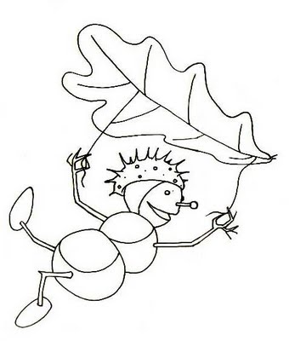
Newsletter
October 2013

Dear parents and children,
believe it or not – the first month of the school year is over and it was definitely a busy month for all of us! Likewise the month of October is full of school events, projects and activities – amusing, educational but also voluntary!
Our Houses shool competition has the first winner! Congratulations to YELLOW HOUSE!!! The photos from the Autumn Fun Day and School Assembly are on our school website. Have a look! Some classes visited the Sokolská Gallery to see David Moješčík´s scuptures. We were looking at them from different points of view and finally came across many interesting thoughts. Children´s perception of an art is truly unique! Even the gallery staff was impressed by children´s interest in art. Similarly, 6.E class broaden their horizons in culture world, specifically in musical field when visiting the concert of Iva Bittová and opera studio. Our first graders got used to school environment very quickly – they swim around here like a fish in a water! Our sixth graders are already big kids since they entered the second stage of primary education. But we are happy to say that they are still nice and always ready to help with everything. They – for example – participate in doing English Reading with children from junior classes. We are glad that all children from bilingual classes support each other and cooperate well, which was more than obvious during the competitions on Autumn Fun Day. Let´s keep going like that!
OCTOBER EVENTS:
2. 10. 10.00 6. E – The Last Samurai, ballet - NDM
10.00 3. E – The Period of Towns and Castles, Ámos Activity Centre
12.00 2. E2 – Animation in Sokolska Gallery, David Moješčík, sculptures
3. 10. 8.00 5. E – Animation in Sokolska Gallery, David Moješčík, sculptures
4. 10. 10. 00 4. E – The Period of Towns and Castles, Ámos Activity Centre
7. 10. 10. 00 5. E – The Period of Towns and Castles, Ámos Activity Centre
11. 10. 1E - 6E - 72 hours project – www.72hodin.cz – Cleaning the park, reading in DPS Gajdošova–more information from your class teachers just before the event (all depends on the weather)

15. 10. 10.30 1. E - Tomcat Modroočko, DLO
18. 10. 3. E, 4. E, 5. E – exhibition The Eyes of Blind, the Ears of Deaf, Černá louka, section A
21. 10. 8.30 2. E1 – Goldilocks – DLO
during the month 1E - 6E - visit of U6, Lower part of Vítkovice – preparation for the Project of Technical – Science Days

28. 10. - Bank Holiday
29. 10. – 30. 10. 2013 - Autumn Holiday
1. 11. - Halloween Funny Science Day + 2nd School Assembly – prepare a costume of some famous scientist!
Other information:

School Library – was opened during the September. It is open every Monday from 2.30 – 4pm and children can spend there a nice time with a book. Both english and czech books can be borrowed and taken home. In case older children need to work on some reviews or presentations – they can found some useful books such encyklopedias or educational books here. There is a printer available if needed and likewise a good advise of the library staff. Later on the computer with Internet connection will be avaliable so as children can look up various information. There will be going on Reading of English Stories for those who would want to spend their time listening, resting and at the same time practising their English language. The Librarian for this school year is Ms. Hanka.
The library will be also opened during other days (Tuesday – Friday), but that is just within the Care Centre, without possibility of taking books home. We ordered lots of new english books – exciting! And also there will be another Book Market during this school year. If you have some spare books that you don´t need anymore – we will happily welcome them in our library!

Collections and Fund Raising Activities in October:

Chestnuts and acorns for animals – dry them out before you bring them to school, please
Lids from plastic bottles – we continue in collecting the lids for charity – the box is placed next to coffee machine
Used Centropen pens – for the purposes of ecological processing with the possibilty of winning some price for our school – labeled box placed in the hallway

We wish you a lovely October
and hopefully some Indian Summer!

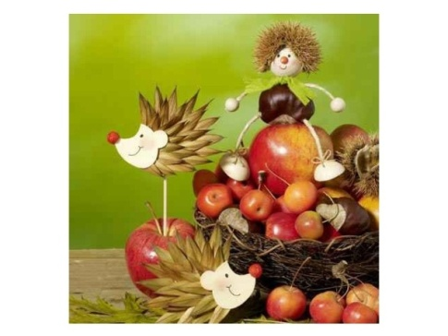
Your OS teachers

