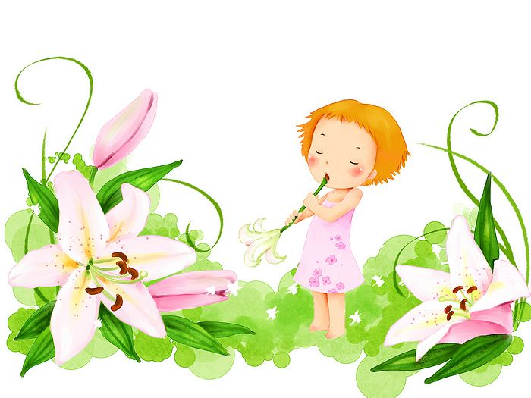
Newsletter
March 2014

Dear parents and children,
another month brings us new events and activities including the whole month project „Oh! Look! I can make a book!“
And we truly look forward to our pupils´ creative art pieces!
Events:
3. 3. 2. – 4.E - „Šikulové“ - filming of programme for Czech Television
4. 3. 3. E - 8.00 – City Police of Ostrava
5. 3. 1. E – 8.00 – lecture in the City Library of Ostrava (bring completed application)
7. 3 - 5th School Assembly + HOUSES
13. 3. 1E – 6E – 8.45 – discussion with Leopold Sulovský, senator and well-known mountaineer, about his climbing expeditions
25. 3. 1E – 6E – 8.30 - concert Jumping Drums – DK Akord
28. 3. - 6th School Assembly + HOUSES
3. 3. – 28. 3. 1E – 6E – Oh! Look! I can make a book!
⇨ this project is related to the month of March - known as a month of a book. We will focus on the book itself: where can we buy the book, where can we borrow the book, how is the book made, what does the cover say about the book, why do we actually read the books and what does reading mean to us.

All classes will present their own class handmade books on Friday 28.3. – 5th lesson. Children can also make another book at home – there are no limits for creativity – and the best three books will be awarded!
Parents can see all these books displayed in the hallway of the 4th floor from 12.35 until 4 pm.

We wish you a beautiful spring time!
OS teachers

