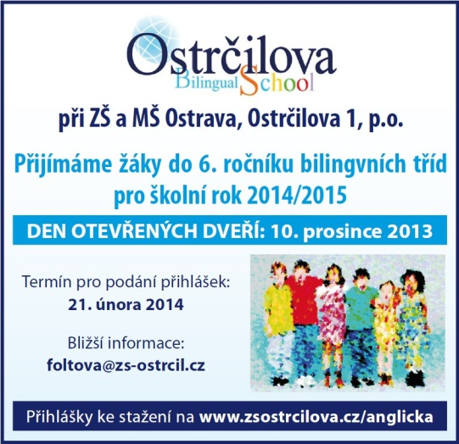
Newsletter
December 2013
Dear parents and children,
we are sure you are already looking forward to Christmas and the Christmas holiday, a time when we´ll all finally have a fantastic rest. In December, too, many interesting events will take place at our school.
The last one of those is intended not only for children, but also for you, parents and relatives. We´ll have now a traditional Coffee Morning with Christmas workshops. During this Christmas morning you can – together with your children – manufacture something nice for yourselves, chat with friends and teachers or have a cup of tea or coffee together. We would like to ask skilful mums, grannies or even fathers to kindly contribute a few Christmas sweets to our refreshment bar, which will be free for everyone to eat or drink. A BOOK FAIR will be a part of this event – again, a USBORNE publishing house´s book market, where, just like in spring, you will be able to buy beautiful English children´s books. You are all welcome!
We would also like to remind you of the Open Doors Day, a day when you have a unique chance to watch the lessons. This day is also a good oportunity for those who may be interested in enrolling their children in bilingual classes. We accept pupils for the future 6th grade who don´t intend to enter grammar schools but don´t want to stay at their secondary schools either. If any of your acquaintances wish to study a bilingual secondary school and to experience a bit different schooling, we will be happy if you would recommend us. If they require any information, it is available on our website www.zsostrcilova.cz or they can contact the Head of the bilingual classes Ms Hanka Foltová.
Plan of events in December
4. 12. 2E2 Christmas Crafts – Ámos Club
5. 12. 2E1 Christmas Crafts – Ámos Club
5. 12. 1 – 3rd Grade St Nicolaus´ distribution of presents
6. 12. 1 – 2nd Grade (a few pupils only) Schools Championship in Chess (TJ Varenská)
9. 12. 2E1 Children´s art work exhibition opening and a prize ceremony (Prague)
10. 12. 8.00 – 11.00; 14.00 – 16. 30 Open Doors Day
11. 12. 2E1, 2E2 Od čerta k Ježíškovi /From a devil to a Christ Child/ – theatre, DKMO
13. 12. 6E Women´s Florball World Championship - cheering
16. 12. 16. - 16.30 Pupils´ Christmas Concert – Masaryk Square
17. 12. 1E, 2E1, 2E2, choir Christmas performance and presents giving in DPS Gajdošova
20. 12. 1E – 6E 8.00 – 10.00 Christmas Coffee Morning and Workshop , UsborneBook Fair
SHORTENED SCHEDULE: primary classes end at 14:40, secondary classes end at 12:00
21. 12. 2013 – 5. 1. 2014 Christmas Holiday
Finally, we congratulate to children from 2E1 who were given prize in art competition „Multilanguage is richness“, organized by a magazine Friends and a House of Minorities in Prague.
We want to give our thanks to everyone who took part in the Chain for Africa charity of Bikes for Africa company. We collected 4218 CZK altogether! We´d also like to thank to 6E pupils who contributed in making of a mascot for the florball championship. Their reward is a chance to cheer one of the matches! Last but not least we must thank all children, teachers and parents who are preparing the Christmas performance, concert and presents. We believe that our deeds will bring joy to everyone they´re meant for.
Thanks for cooperation and hope to see you soon!
Your OS Teachers

