Newsletter April 2014
Dear parents and children,
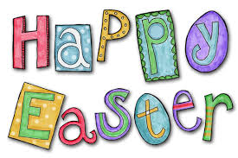
last month went quickly as it was full of hard work but it was also full of some great events so let´s summarize it first!
Right at the beginning of the month – children were filming „Šikulové“ for Czech television. Then we met with senator Mr. Sulovský, who told us everything about his expedition to Lhotse. It was very interesting and children had hundreds of questions as if they were planning an expedition there too?! :-)
Towards the end of March we went to a concert called Jumping Drums. What an enthusiastic response from the children of all grades and even from the teachers! The rhythm was so contagious that it made us all to tap on our legs :-)

All grades from 1E to 6E took part in our project called „Oh! Look! I can make a book!“ Everybody put lots of energy, time and invention in it. Every class was busy creating their class book and some children worked also at home to make their own special original book and the results are awesome! Moreover some classes did „to be continued“ reading with their teachers or parents or with 400 years old ghost called Xaver! Children presented their favourite books within „Show and Tell“ activity. We welcomed a special guest Zuzana Pospíšilová at our school last week. Mrs. Pospíšilová is a favourite author of children´s books and also a pleasant person who told us everything about writing books for children.
On Friday 28th March we announced the results of our School Assembly. At the same day – all calsses presented their class books, which are truly wonderful pieces of art: books about friends, a book about animals, a pillow book of dreams a book about our school but also a book about the faraway countries. All classes were awarded for their amazing work – Pizza party! Home made books were awarded too – we had six winners and each of them got a book with dedication. The winners are: Barča Vaňková, Lucka Duráková, Amálka Velkoborská, Alissa Bebko, Magda Červená a Amálka Krčíková... Congratulations!
All the books are on the display in the hallway from 31.3. throughout the whole week and later in our library.

Congratulations go also to children from 2E1, who took part in art competition called „Ireland through children´s eyes“ and succeeded! Therefore they met with ambassadress of Ireland Mrs. Alison Kelly who awarded them with a beautiful book about this emerald island.

APRIL EVENTS:
3. 4. 4. E – 8.00 – 12.35 – Traffic playground
some children - preparation for Easter Exhibition and Poetry Reading in The Nursing House on Gajdošova Street.
15. 4. all classes - 16. 00 – 17. 30, Individual consultation about study results and behaviour

We kindly ask all parents to check the „Lost and Found Box“ in the hallway, there might be something you sent to school together with your child and it didn´t come back home...
16. 4. 1E – 6E - EASTER FUN DAY
17. 4. – 21. 4. - Easter Holiday
23. 4. 1. E – 8.30 - „O víle menší než zrnko máku“ – DLO
25. 4. 1E – 5E - Earth Day – „Let´s clean the forest!“ – trip to the nature
- 7th School Assembly – Houses

„EASTER EXHIBITION ALIAS CREATE IN THE SPIRIT OF EASTER“

We announce a voluntary activity for children and the whole families. Let´s prepare an interesting Easter themed display to show the traditions of our country. You can bring your hand-made artefact until Wednesday 9th April and hand it over to your class teacher. The reawrd won´t miss you! The display will please the seniors in The Nursing House on Gajdošova Street. From Monday 14th it will be placed in our hallway. Thank you for your support!

We wish you nice April and joyful Easter!
OS teachers
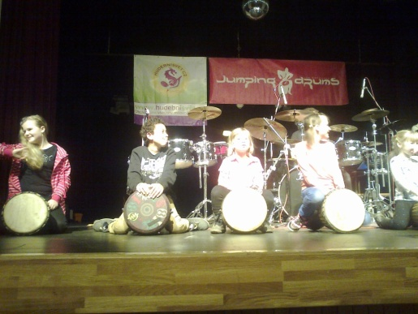
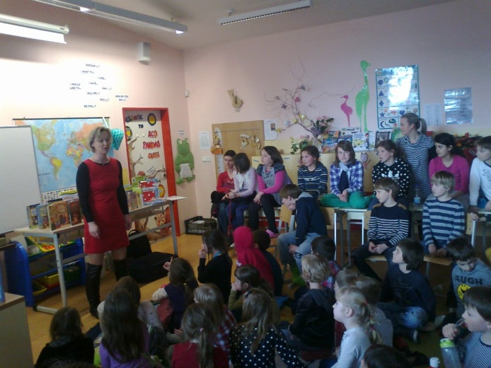

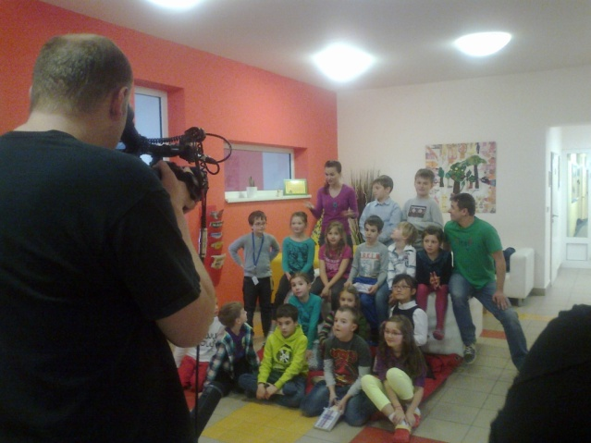

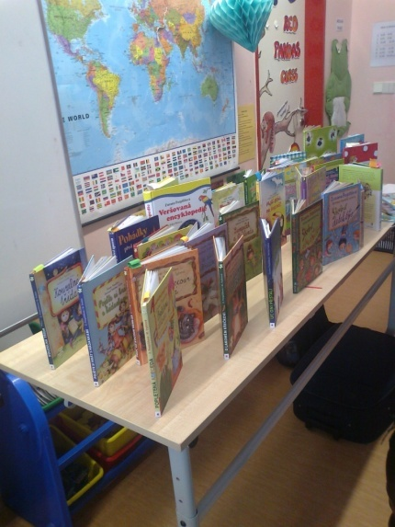
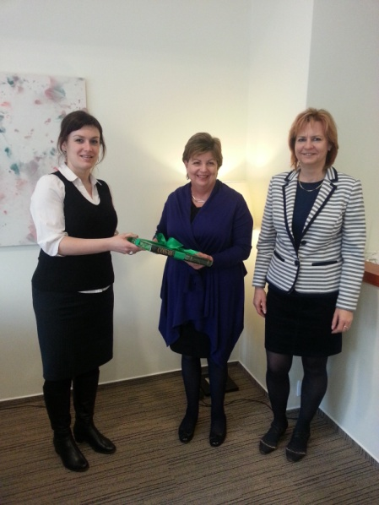

NAŠI ŠIKULOVÉ V TELEVIZI:
http://www.ceskatelevize.cz/porady/10120743066-sikulove/414234100081008/

